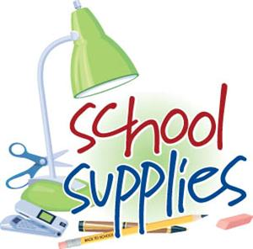
BMS 6th Grade

Gibbs (Math & World Geography)
- (2) Three-ring binders, 1 ½ or 2 inch
- Dividers for each binder

Wish List
These items aren't required, but are much appreciated! These are supplies we use in both classrooms on a regular basis. We assigned items for boys and girls to make the shopping a bit easier, but we will appreciate any items you would like to send!
- Boys: Clorox/Lysol Wipes, index cards OR Post-it notes, pack of red pens
- Girls: Color Copy Paper (for group use and projects), Expo Markers (unscented), Kleenex Tissues

- Loose leaf paper for each binder
- (1) pack Graph Paper
- Highlighters, No. 2 Pencils

Worley (Language Arts & Science)
- (2) Three-ring binders, 2 inch.
- Dividers for each binder
- Loose leaf paper for each binder
- Composition notebook
- No. 2 Pencils

